**DRC Yellow Fever surveillance and laboratory data   
(Handover notes)**

Contents

Key focal points 1

Current data flow 2

Proposed data flow (decentralisation of data entry) 3

In country generic email 4

Classification committee meeting 5

Data cleaning 6

# Key focal points

|  |  |  |  |  |
| --- | --- | --- | --- | --- |
| **Country** | **Person** | **Role** | **Email** | **Phone/ GPN** |
| DRC | Tiekoura COULIBALY | Incident managers | [coulit@yahoo.fr](mailto:coulit@yahoo.fr) |  |
| DRC | Lubambo DEMBA | [dembalu@who.int](mailto:dembalu@who.int) | +812688435243 |
| DRC | Vincent SODJINOU | Incident manager (cholera) | [sodjinouv@who.int](mailto:sodjinouv@who.int) |  |
| DRC | Albert MBULE | Data manager | [mbulea@who.int](mailto:mbulea@who.int) | +243817150526 |
| DRC | Robert KUZANWA | Data collection | [kuzanwar@who.int](mailto:kuzanwar@who.int) | +243817160025 |
| DRC | Sie KOUADIO | Data manager | [kouadios@who.int](mailto:kouadios@who.int) | +243825630765 |
| DRC | Henriette NGOMA | Data entry clerk | [ngomanriette@yahoo.fr](mailto:ngomanriette@yahoo.fr) | +243815027512 |
| DRC | Loms LOMBELELO ANDJAFUMBA | Classification committee | [lombeleloandjafumbal@who.int](mailto:lombeleloandjafumbal@who.int) | +243820364697 |
| DRC | Steve AHUKA | INRB (Data manager) | [amstev04@yahoo.com](mailto:amstev04@yahoo.com) |  |
| DRC | Jean CLAUDE | INRB (Data manager) | [changaclaudel@yahoo.fr](mailto:changaclaudel@yahoo.fr) | +243998308388 |
| DRC | Eeva KUISMA | Kahemba mobile lab (Team lead) | [emlab.drc@yahoo.com](mailto:emlab.drc@yahoo.com) | +243828737349 |
| DRC | Ernest DABIRE | Health cluster coordinator | [dabireer@who.int](mailto:dabireer@who.int) | [+243817006416](tel:%2B%28243%29%20817-006-416) |
| DRC | Louis ILLUNGA | IT | [ilungal@who.int](mailto:ilungal@who.int) | +243817006404 |
| BRA | Ambrose TALISUNA | Incident manager | [talisunaa@who.int](mailto:talisunaa@who.int) | +47 241 39 155 |
| BRA | Etienne MINKOULOU | Data manager | [minkouloue@who.int](mailto:minkouloue@who.int) | +24269523377 /39680 |
| BRA | Anaclet NGANGA KOUBEMBA | Data manager | [ngangakoubembaa@who.int](mailto:ngangakoubembaa@who.int) | 069879224 |

# Current data flow

There are two sites currently entering **surveillance data** from case investigation forms:

* Kinshasa hub (entering case investigation forms into epiinfo from Kinshasa),   
  Kinshasa country office (entering case investigation forms into epiinfo from **all** provinces excluding Kinshasa)

The **laboratory data** is being sent in excel format every day and is currently being entered in to the Epiinfo database in the country office.

|  |  |
| --- | --- |
| **Challenges** | **Proposed solutions/ activities** |
| No data entry person in the country office/ data managers do not have enough time to enter data | * Train Henriette Ngoma to enter all case investigation forms from all provinces and laboratory data in to EpiInfo OR * Recruit a data entry clerk to fill the role in the country office until the data entry is decentralised |
| Database is not archived or stored in an accessible place | * Create a generic email for use in the country office for all data managers working on yellow fever **(see *In country generic email* section below)** * Access to be managed by the incident manager * Yellow fever global database will allow the data to be archived and stored in a data repository |
| Database is not shared within country office | * The creation of the generic email will help open access to others who require the database to help inform decisions **(see *Data sharing section* and C*lassification committee meeting* section)** * Yellow fever global database access to be given to other data managers working in the country office |
| Frequency of database sharing | * Establish an agreement between all three levels (HQ, AFRO, Country office) of when the database will be shared (Every Tuesday or Wednesday – to clarify) |
| Cleaning of EpiInfo database | * EpiInfo database needs to be harmonised with laboratory database **(See *Data cleaning* section)** * Decentralisation of the data entry will help in reducing missing fields and will give the data managers in the country office more time to clean the consolidated database |
| Harmonisation of the 4 databases (Laboratory database, Classification committee data, EpiInfo database and MoH database) | * Classification committee focal point and YF data manger to discuss streamlining the process of harmonising laboratory database, classification committee data and EpiInfo database. * Focal point who attends the classification committee meetings regularly should be involved in this discussion |

# Proposed data flow (decentralisation of data entry)

Surging capacity in the 5 provinces, Matadi, Kananga, Lubumbashi, Bandundu, and Kahemba (all have WHO suboffices except for Kahemba) to allow the surveillance and laboratory data to be entered at the provincial level. The epiinfo files can then be sent electronically to the country office for merging into one database.

***Yellow fever proposed data flow in DRC as of 21 August****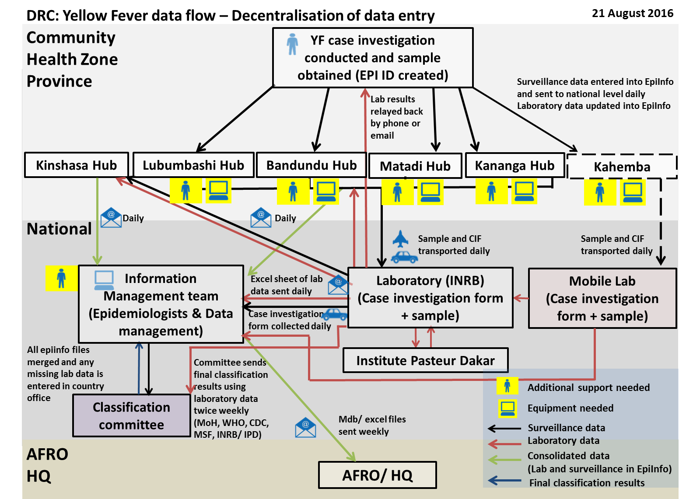*

|  |  |
| --- | --- |
| **Challenges** | **Proposed solutions/ activities** |
| Managing the data flow as the data will come from 6 separate sites and needs to be merged | * Key focal point at the country office will be responsible for merging and cleaning the data from the 6 provinces * Generic email will help to keep track of incoming files and opens up access so that multiple data managers can work on consolidating data |
| Data quality as a result of decentralisation of data entry (data entry clerks at various locations may result in inconsistencies during data input) | * Training of each data entry clerk needs to be as comprehensive as possible * SOPs for entering data should be compiled |
| Internet connectivity for sending of data may be limited at remote sites | * Conduct needs assessment at each data entry point |
| Time to implementation as vaccination campaign is ongoing until 26 August | * Finalise implementation of data flow as soon as possible * Create clear and realistic timelines in the implementation plan for the decentralisation of data entry |
| Additional resources in the country office until first week of September | * Focal point in the country office needs to be responsible for the decentralisation of data entry |

# In country generic email

|  |  |
| --- | --- |
| **Challenges** | **Proposed solutions/ activities** |
| Currently database is not shared within the country office | * Creation of the generic mailbox will open up access to others who require the database immediately for decision making (eg. in the classification committee meeting) |
| Tracking the files sent once the data entry has been decentralised | * Generic mailbox will help to keep track of files and set up reminders to the focal points in each province * The email should be set up in parallel with the decentralisation of the data entry |
| Controlling access to the generic email | * Clear SOPs need to be written regarding use and access of the generic email |
| Managing the generic email |

***Tracking yellow fever data once the data entry is decentralised***

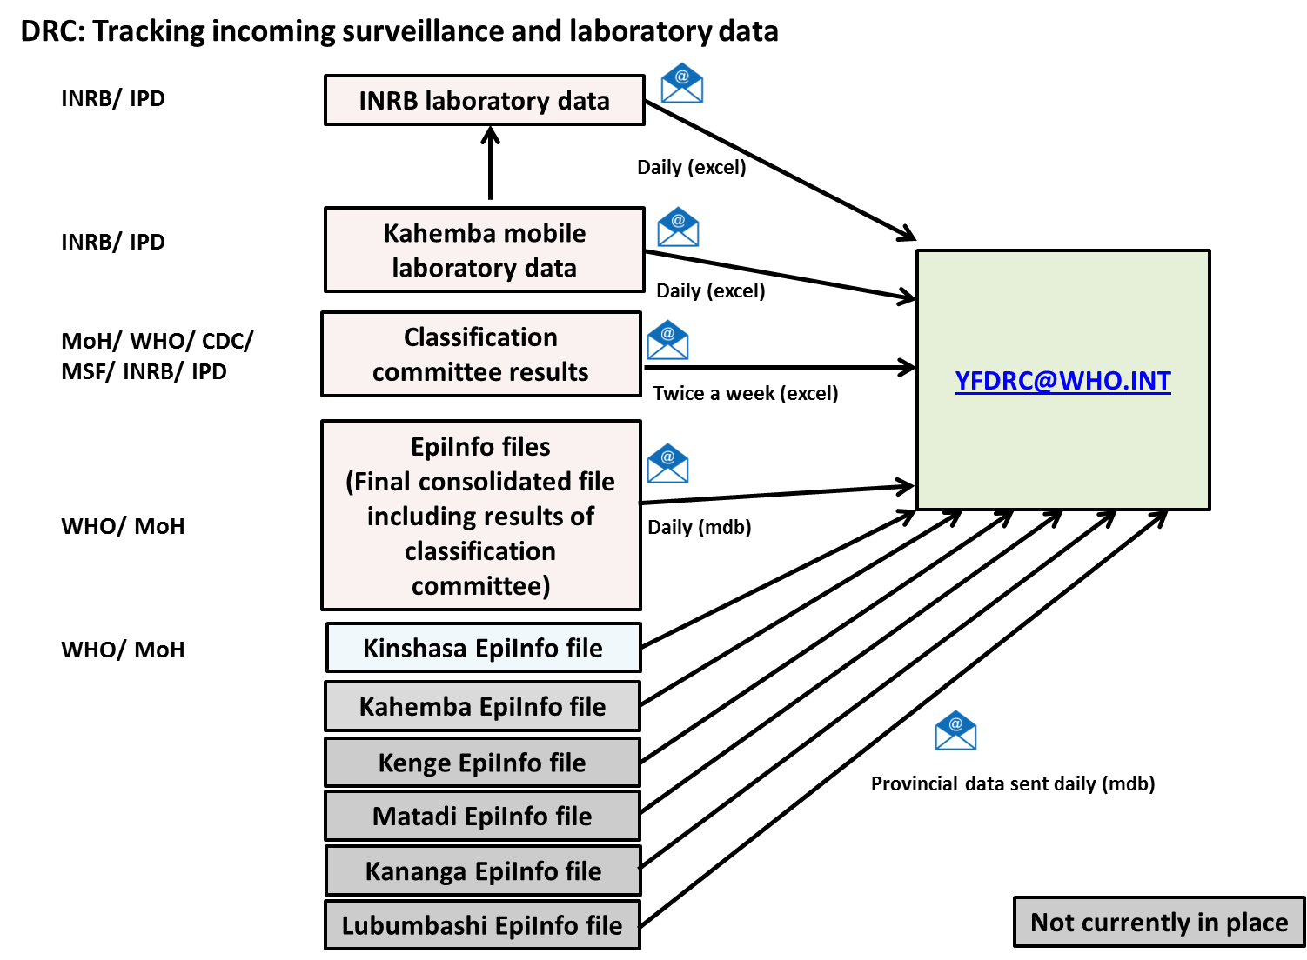

# Classification committee meeting

Classification committee meeting meets twice a week usually on Monday and Thursday around 10am. Attendees include focal points from the following organisations: MoH, INRB, IPD, CDC and MSF. Invitation is sent from the MoH the day before or on the day to attend the meeting. Follow up with Dr Lom’s if wishing to attend the meeting.

|  |  |
| --- | --- |
| **Challenges** | **Proposed solutions/ activities** |
| Updating information from the classification committee meeting into EpiInfo database | * This needs to be done regularly following each classification committee meeting |
| Focal point attending the classification meeting twice a week does not have access to the latest EpiInfo database | * Meet with classification committee focal point and YF data manager to ensure that the EpiInfo database is shared twice a week before the classification committee meetings * Any missing information for cases with IgM and PCR positive should be followed up in the period in between the classification committee meetings * This process will facilitate the harmonisation of 3 of the databases (Laboratory database, Classification committee data and EpiInfo database) |
| Data in the EpiInfo database is missing information that is in the laboratory database | * Harmonise laboratory and EpiInfo databases so that the EpiInfo database can be used during the classification committee meeting |
| Data sharing between other partners (MoH, INRB, IPD, CDC, MSF) | * Focal point who attends the classification committee meetings regularly should be involved in this discussion |

# Data cleaning

Updating EpiInfo form to match paper CIF/ YF global database:

|  |  |  |
| --- | --- | --- |
| **Activity** |  |  |
| **Updating the following fields in the EpiInfo data entry form** | ***Travel in the last 3 weeks*** | Add unknown option |
| ***Was the patient vaccinated*** | Add 9 unknown option |
| ***Hospitalised*** | Add unknown option |
| ***Inout patient/ statut malade*** | Make read only |
| ***Blank variable1*** | Can this be removed/ made read only |
| ***Blank variable 2*** | Can this be renamed to ‘vaccination status’ |
| ***Vaccination status*** | Impute this variable?  Eg. If ***was the a patient vaccinated* =** yes & **date of vaccination =** entered **🡪vaccination with card** Check with Albert whether we should impute this? |
| ***Date of vaccination vs Date of last vaccination*** | To check if it is the same question |
| **Data quality checks in epiinfo** | Align the data quality checks in epi info with the fixed variables which are required in the YF global database to ensure they are not missing/ dates are correct. | |
| **Data dictionary** | Check with Albert whether one currently exists. If not, data dictionary for DRC database needs to be created. | |

**Cleaning of epiinfo database from laboratory database (in order of prioritisation):**

|  |  |
| --- | --- |
| **Activity** |  |
| Albert to delete duplicates |  |
| Cross-check EpiInfo and lab database and create list of case investigation forms that are not in EpiInfo form |  |
| Send list to INRB and data entry clerk to enter case investigation forms that are missing from the EpiInfo database |  |
| Compile list of IDs where the paper CIFs need to be checked against |  |
| Trace original CIFs and correct incorrect information entered in EpiInfo database |  |
| Add all laboratory results from laboratory database in to EpiInfo database |  |
| Check and harmonise IDs between EpiInfo database and laboratory database |  |
| Vaccination doses column needs to be cleaned |  |
| Additional data validation checks (eg. dates that should be consecutive) |  |